Experiment 2
TABLE
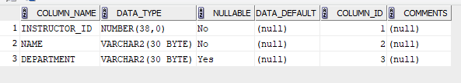
Course
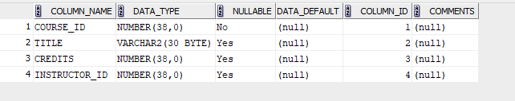
Student
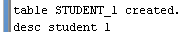
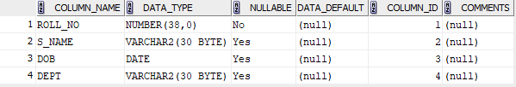
Entrollment
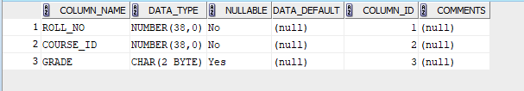
INDICES

DROP
